E-Waste Awareness Analysis Using Hypothesis Testing and Machine Learning

Abstract
Electronic waste (E-Waste) has become one of the fastest-growing environmental concerns worldwide due to rapid technological advancement and improper disposal practices. This study aims to analyze awareness and disposal behavior regarding E-Waste among respondents using statistical hypothesis testing and machine learning techniques. Data was collected through a structured Google Forms questionnaire consisting of multiple-choice questions related to awareness, recycling practices, environmental concerns, and disposal behavior.
The project applies Chi-Square Hypothesis Testing to determine whether demographic variables significantly influence E-Waste awareness. Additionally, Random Forest Classification was used to predict awareness levels using demographic variables such as age, gender, and education level. The study found that gender and E-Waste awareness are statistically independent, while age and education showed greater influence in predictive analysis.

1. Introduction
Electronic waste, commonly referred to as E-Waste, includes discarded electronic devices such as computers, mobile phones, televisions, batteries, and other digital equipment. Improper disposal of E-Waste can lead to severe environmental and health hazards because electronic devices often contain toxic substances such as lead, mercury, and cadmium.
With increasing dependency on technology, E-Waste generation has increased significantly. However, awareness regarding safe disposal and recycling practices remains limited among many individuals. Therefore, understanding awareness levels and behavioral patterns regarding E-Waste management is essential.
This project focuses on analyzing awareness levels among respondents and identifying factors influencing responsible E-Waste disposal behavior.

2. Objectives of the Study
The objectives of this project are:
- To analyze awareness regarding E-Waste among respondents.
- To study the relationship between gender and E-Waste awareness.
- To apply hypothesis testing using the Chi-Square Test of Independence.
- To predict awareness levels using machine learning techniques.
- To identify the most influential demographic factors affecting awareness.

3. Research Methodology

3.1 Data Collection
Data was collected using Google Forms through a structured questionnaire consisting of multiple-choice questions.
The questionnaire included:
- Demographic information
- Awareness regarding E-Waste
- Recycling practices
- Disposal behavior
- Environmental concerns
- Awareness campaigns

3.2 Dataset Information
- Total Responses: 65
- Total Variables: 21
- Data Type: Categorical Survey Data
- File Format: Excel (.xlsx)

3.3 Tools and Technologies Used
Tool / Technology | Purpose
Python | Data Analysis
Pandas | Data Manipulation
NumPy | Numerical Computation
Matplotlib | Data Visualization
Seaborn | Statistical Visualization
Scikit-Learn | Machine Learning
SciPy | Hypothesis Testing
PyCharm | Development Environment

4. Data Pre-processing
Before analysis, the dataset underwent preprocessing steps.

4.1 Null Value Checking
The dataset was checked for missing values using:
print(df.isnull().sum())
No missing values were found in the dataset.

4.2 Duplicate Removal
Duplicate responses were removed using:
df.drop_duplicates(inplace=True)

4.3 Label Encoding
Since machine learning algorithms cannot process text-based categorical data directly, Label Encoding was applied.
Example:
Original Value | Encoded Value
Male | 1
Female | 0
Yes | 1
No | 0
Label Encoding was implemented using:
from sklearn.preprocessing import LabelEncoder
5. Exploratory Data Analysis

5.1 Gender Distribution
A count plot was generated to visualize respondent distribution across gender categories.
Observation
- Female respondents constituted the majority of participants.
- Male respondents formed the second-largest group.
- Very few respondents selected “Prefer not to say”.

Interpretation
The survey dataset was dominated by female participants, indicating greater participation from female respondents in the study.
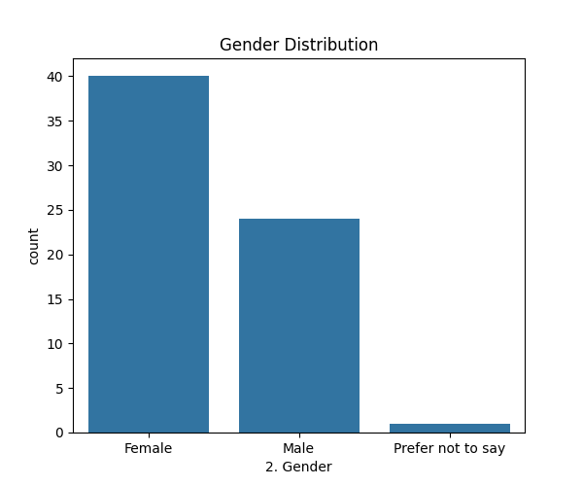

5.2 Correlation Heatmap
A correlation heatmap was generated to study relationships among variables after label encoding.

Observations
- Awareness-related variables showed moderate positive correlations.
- Gender showed weak correlations with awareness-related variables.
- Education level displayed moderate influence on awareness and recycling behavior.

Interpretation
The heatmap suggested that demographic variables such as age and education may influence E-Waste awareness more significantly than gender.
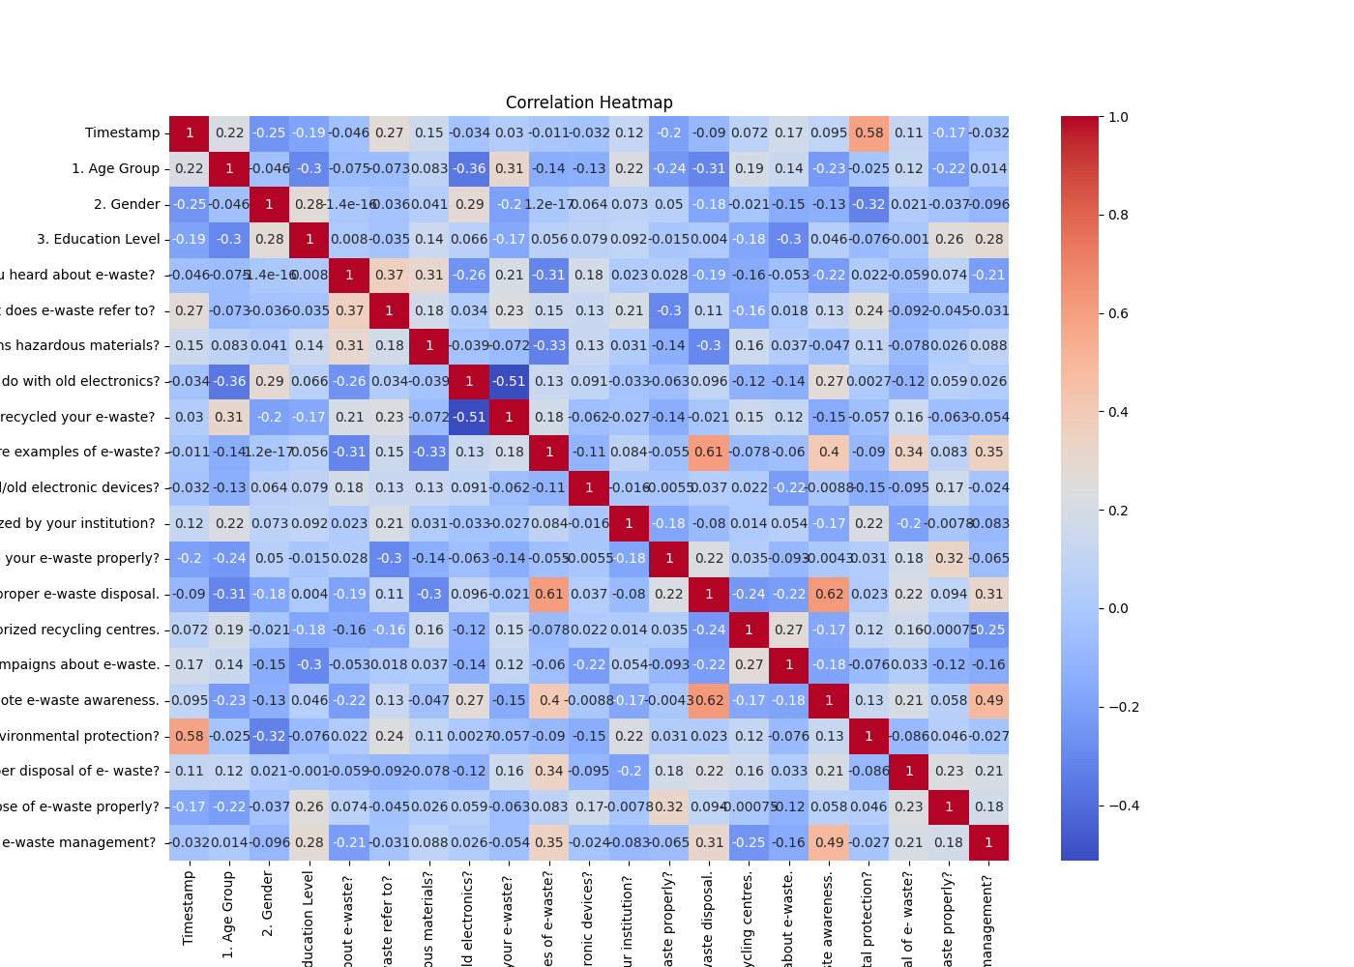

6. Hypothesis Testing

6.1 Hypothesis Formulation

Null Hypothesis (H₀)
Gender and E-Waste Awareness are independent.

Alternative Hypothesis (H₁)
Gender and E-Waste Awareness are dependent.

6.2 Statistical Test Used
The Chi-Square Test of Independence was applied because both variables were categorical.

Chi-Square Formula
χ² = Σ ((Observed − Expected)² / Expected)
The test was implemented using:
chi2_contingency()
6.3 Contingency Table
Gender | Not Aware | Aware
Female | 3 | 37
Male | 2 | 22
Prefer not to say | 0 | 1
6.4 Chi-Square Test Results
Parameter | Value
Chi-Square Value | 0.0993
P-value | 0.9515
Degrees of Freedom | 2
6.5 Decision Rule
- If p-value < 0.05 → Reject H₀
- If p-value > 0.05 → Fail to Reject H₀
Since:
0.9515 > 0.05
The null hypothesis was accepted.
6.6 Interpretation
The results indicate that Gender and E-Waste Awareness are statistically independent.
This suggests that awareness levels regarding E-Waste are similar across gender categories.

6.7 Hypothesis 2: Gender and Ownership of Unused Electronic Devices

Null Hypothesis (H₀)
Gender and ownership of unused electronic devices are independent.

Alternative Hypothesis (H₁)
Gender and ownership of unused electronic devices are dependent.

6.8 Contingency Table for Hypothesis 2
Gender | Does Not Own Unused Devices | Owns Unused Devices
Female | 13 | 27
Male | 7 | 17
Prefer not to say | 0 | 1

6.9 Chi-Square Test Results for Hypothesis 2
Parameter | Value
Chi-Square Value | 0.5296
P-value | 0.7673
Degrees of Freedom | 2

6.10 Interpretation of Hypothesis 2
Since the p-value obtained was greater than the significance level of 0.05, the null hypothesis was accepted.
This indicates that Gender and ownership of unused electronic devices are statistically independent.
The findings suggest that the tendency to own or store unused electronic devices does not significantly differ across gender categories.

7. Machine Learning Analysis
7.1 Machine Learning Technique Used
Random Forest Classification was used for predictive analysis.
7.2 Reason for Selecting Random Forest
Random Forest was selected because:
- It handles categorical data effectively after encoding.
- It provides high prediction accuracy.
- It reduces overfitting.
- It provides feature importance analysis.
7.3 Features and Target Variable
Input Features
- Age Group
- Gender
- Education Level
Target Variable
- Awareness regarding E-Waste
7.4 Train-Test Split
The dataset was divided into:
- 80% Training Data
- 20% Testing Data

7.5 Model Accuracy
Metric | Value
Accuracy | 84.6%

Interpretation:
The Random Forest model correctly predicted awareness levels with approximately 84.6% accuracy.

7.6 Classification Report
The model performed well in predicting respondents who were aware of E-Waste.
However, lower performance for the minority class occurred because the dataset was imbalanced, with most respondents already being aware of E-Waste.

7.7 Confusion Matrix Analysis

Observations
- 11 respondents were correctly predicted as aware.
- 2 respondents who were not aware were incorrectly predicted as aware.

Interpretation
The model was highly effective in predicting the majority awareness class.
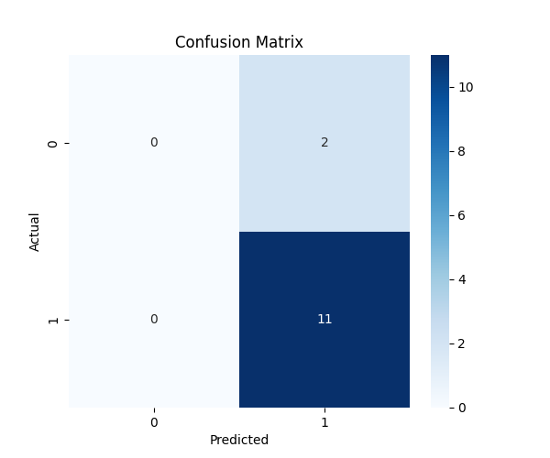

7.8 Feature Importance Analysis
Feature importance scores indicated:
Feature | Importance
Age Group | Highest
Education Level | Moderate
Gender | Moderate

Interpretation
Age Group emerged as the most influential factor affecting E-Waste awareness.
This suggests that awareness levels vary more significantly across age groups than across gender categories.

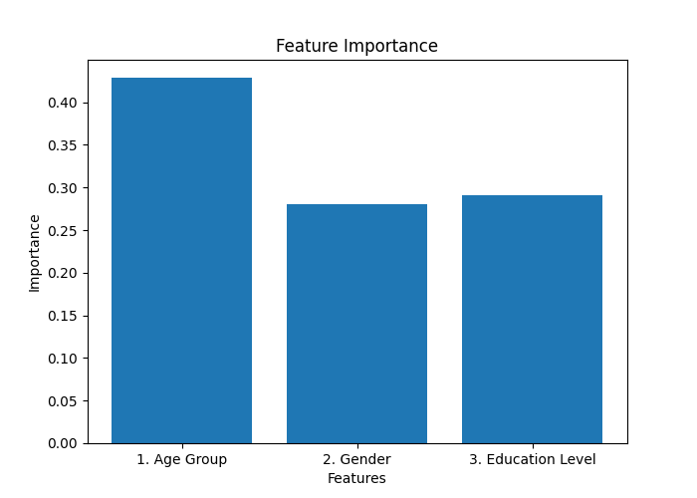

8. Findings of the Study
The major findings of the project are:
- Most respondents were already aware of E-Waste.
- Gender does not significantly influence awareness levels.
- Age Group was the strongest predictor of awareness.
- Education level also contributed to awareness prediction.
- Random Forest Classification achieved good predictive accuracy.
- Respondents showed positive attitudes toward environmental protection and responsible disposal practices.

9. Conclusion
The study successfully analyzed E-Waste awareness and disposal behavior using statistical and machine learning techniques.
Chi-Square Hypothesis Testing revealed that Gender and E-Waste Awareness plus Gender and E-Waste Generation are statistically independent. Random Forest Classification further demonstrated that demographic variables such as age and education are more influential in predicting awareness levels.
The project highlights the importance of educational initiatives and awareness campaigns in improving responsible E-Waste disposal behavior. The findings can help institutions and policymakers design targeted environmental awareness programs.

10. Limitations of the Study
- The dataset size was relatively small.
- The survey responses were limited to a specific respondent group.
- The dataset was imbalanced because most respondents were already aware of E-Waste.
- The study focused mainly on demographic predictors.

11. Future Scope
Future improvements may include:
- Collecting larger datasets.
- Including behavioral and socioeconomic variables.
- Applying advanced machine learning algorithms.
- Performing sentiment analysis on open-ended responses.
- Developing predictive awareness dashboards using Power BI.

12. References
- Research papers on E-Waste Management
- Scikit-Learn Documentation
- Pandas Documentation
- SciPy Documentation
- Environmental Protection Agency (EPA) resources on E-Waste

Appendix

Python Libraries Used:
import pandas as pd
import numpy as np
import matplotlib.pyplot as plt
import seaborn as sns
from scipy.stats import chi2_contingency
from sklearn.preprocessing import LabelEncoder
from sklearn.model_selection import train_test_split
from sklearn.ensemble import RandomForestClassifier
from sklearn.metrics import accuracy_score, confusion_matrix, classification_report

